SMS RECRUITMENT LOGIC MANUAL

Table List

No | Table Name
1 | SR_DivisionMaster
2 | SR_PositionMaster
3 | SR_TemplateMaster
4 | SR_BatchSMSHeader
5 | SR_BatchSMSDetail
6 | SR_SentItem
7 | SR_Inbox
8 | SYS_SourceOfDoc_Hdr
9 | SYS_SourceOfDoc_Dtl

Screen SRM0100 – DivisionList

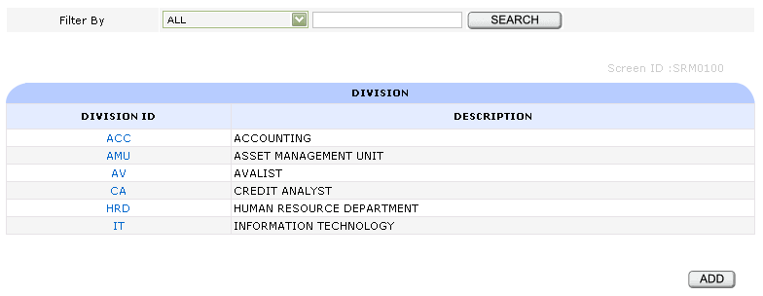

- Fungsi
- Menampilkan daftar Divisi

- Table
- SR_DivisionMaster

- Filter
- Division ID
- Description

- Button / Hyperlink
      - Add
- Link ke DivisionView
- Query String
- FormMode
      - Division ID
- Link ke DivisionView
- Query String
- FormMode
- NoDataDivision

Screen SRM0101 – DivisionView

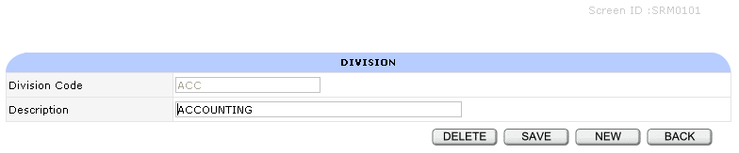

- Fungsi
- Menampilkan, menambah, mengubah dan menghapus data Divisi

- Table
- SR_DivisionMaster

- Button
      - New
- Link ke DivisionView
- Query String
- FormMode
      - Save
- Insert data ke Table SR_DivisionMaster
- Link ke DivisionList
- Query String
- FormMode
      - Delete
- Delete data dari Table SR_DivisionMaster By NoDataDivision
- Link ke DivisionList
- Query String
- FormMode
      - Back
- Link ke DivisionList
- Query String
- FormMode

- Validasi
      - Saat Delete, jika Divisi sudah terlibat dalam suatu transaksi, tidak boleh dihapus
      - Saat Save, DivisionID tidak boleh ada di database
      - Saat Save, DivisionID dan Description harus diisi

Screen SRM0200 – PositionList

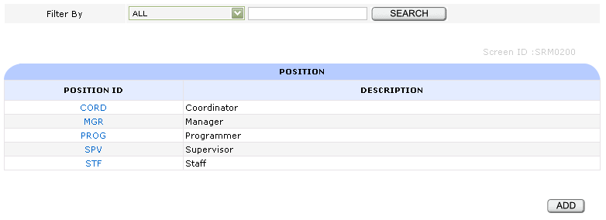

- Fungsi
- Menampilkan daftar Posisi

- Table
- SR_PositionMaster

- Filter
- Position ID
- Description

- Button / Hyperlink
      - Add
- Link ke PositionView
- Query String
- FormMode
      - Position ID
- Link ke PositionView
- Query String
- FormMode
- NoDataPosition

Screen SRM0201 – PositionView

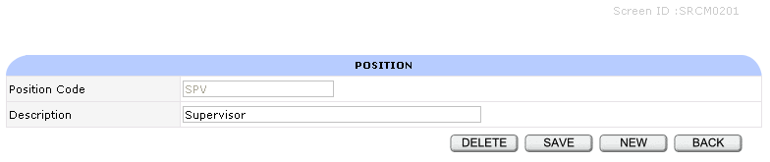

- Fungsi
- Menampilkan, menambah, mengubah dan menghapus data Posisi

- Table
- SR_PositionMaster

- Button
      - New
- Link ke DivisionView
- Query String
- FormMode
      - Save
- Insert data ke Table SR_PositionMaster
- Link ke PositionList
- Query String
- FormMode
      - Delete
- Delete data dari Table SR_PositionMaster By NoDataPosition
- Link ke PositionList
- Query String
- FormMode
      - Back
- Link ke PositionList
- Query String
- FormMode

- Validasi
      - Saat Delete, jika Posisi sudah terlibat dalam suatu transaksi, tidak boleh dihapus
      - Saat Save, PositionID tidak boleh ada di database
      - Saat Save, PositionID dan Description harus diisi

Screen SRM0300 – TemplateList

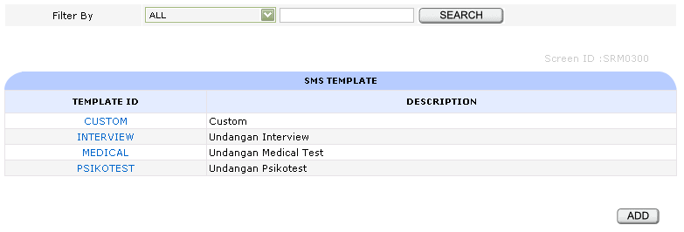

- Fungsi
- Menampilkan daftar Template

- Table
- SR_TemplateMaster

- Filter
- Template ID
- Description

- Button / Hyperlink
      - Add
- Link ke Template View
- Query String
- FormMode
      - Template ID
- Link ke TemplateView
- Query String
- FormMode
- NoDataTemplate

Screen SRM0301 – TemplateView

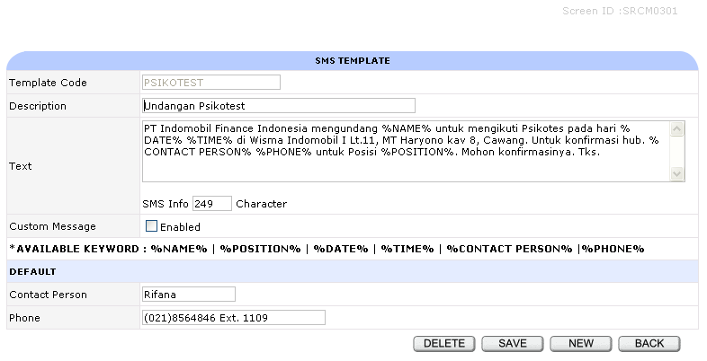

- Fungsi
- Menampilkan, menambah, mengubah dan menghapus data Template

- Table
- SR_TemplateMaster

- Button
      - New
- Link ke TemplateView
- Query String
- FormMode
      - Save
- Insert data ke Table SR_TemplateMaster
- Link ke TemplateList
- Query String
- FormMode
      - Delete
- Delete data dari Table SR_TemplateMaster By NoDataTemplate
- Link ke TemplateList TemplateList
- Query String
- FormMode

      - Back
- Link ke TemplateList
- Query String
- FormMode

- Validasi
      - Saat Delete, jika Template sudah terlibat dalam suatu transaksi, tidak boleh dihapus
      - Saat Save, TemplateID tidak boleh ada di database
      - Saat Save, Jika Custom Message tidak Enabled maka PositionID, Description, Text, Contact Person, Phone harus diisi

Screen SRT0100 – SendSMSInput

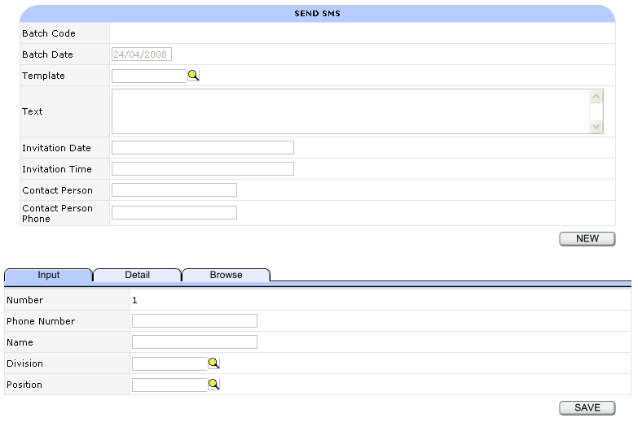

- Fungsi
- Menampilkan, menambah, mengubah dan menghapus data Batch SMS

- Table
- SR_BatchSMSHeader
- SR_BatchSMSDetail

- Reference Table
- SR_DivisionMaster
- SR_PositionMaster
- SR_TemplateMaster

- Button
      - New
- Link ke SendSMSInput
- Query String
- FormMode
- SaveMode
- StatusBatch

      - Save
Jika SaveMode = “” atau SaveMode = “ALL” :
- Update Table SYS_SourceOfDoc_Dtl
- Insert data ke Table SR_BatchSMSHeader
- Insert data ke Table SR_BatchSMSDetail
- Link ke SendSMSInput
- Query String
- FormMode
- SaveMode
- StatusBatch

Jika SaveMode = “DETAIL” :
- Insert data ke Table SR_BatchSMSDetail By NoDataBatchSMSHeader
- Link ke SendSMSInput
- Query String
- FormMode
- SaveMode
- StatusBatch

      - Delete
- Delete semua data dari Table SR_BatchSMSDetail By NoDataBatchSMSHeader
- Delete data dari Table SR_BatchSMSHeader By NoDataBatchSMSHeader
- Link ke SendSMSInput
- Query String
- FormMode
- SaveMode
- StatusBatch
      - Clear
- Menghapus field input Recipient
- Link ke SendSMSInput
- Query String
- FormMode
- SaveMode
- StatusBatch

- Validasi
      - SMS Status
- Open
- Sent
      - Template, Division dan Position harus sesuai Table Master

- Tabulasi
      - Detail
- Link ke SendSMSDetail
- Query String
- FormMode
- SaveMode
- StatusBatch
      - Browse
- Link ke SendSMSBrowse
- Query String
- FormMode
- SaveMode
- StatusBatch

Screen SRT0101 – SendSMSDetail

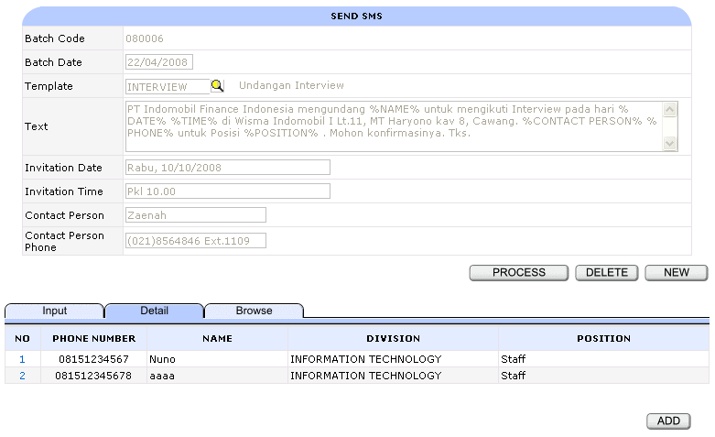

- Fungsi
- Menampilkan data detil, memproses dan menghapus data Batch SMS

- Table
- SR_BatchSMSHeader
- SR_BatchSMSDetail

- Reference Table
- SR_DivisionMaster
- SR_PositionMaster
- SR_TemplateMaster

- View
- vSR_BatchSMSDetail

- Button / Hyperlink
      - New
- Link ke SendSMSInput
- Query String
- FormMode
- SaveMode
- StatusBatch
      - Process
- Link ke SendSMSConfirmation
- Query String
- FormMode
- SaveMode
- NoDataBatchSMSHeader
- StatusBatch
      - Delete
- Delete semua data dari Table SR_BatchSMSDetail By NoDataBatchSMSHeader
- Delete data dari Table SR_BatchSMSHeader By NoDataBatchSMSHeader
- Link ke SendSMSInput
- Query String
- FormMode
- SaveMode
- StatusBatch
      - Add
- Link ke SendSMSInput
- Query String
- FormMode
- SaveMode
- StatusBatch
- ClearSession
      - Nomor Recipient
- Link ke SendSMSInput
- Query String
- FormMode
- NoDataBatchSMSHeader
- BatchSMSDetailNo
- SaveMode
- StatusBatch
- ClearSession

- Tabulasi
      - Input
- Link ke SendSMSInput
- Query String
- FormMode
- SaveMode
- StatusBatch
      - Browse
- Link ke SendSMSBrowse
- Query String
- FormMode
- SaveMode
- StatusBatch

Screen SRT0101 – SendSMSConfirmation

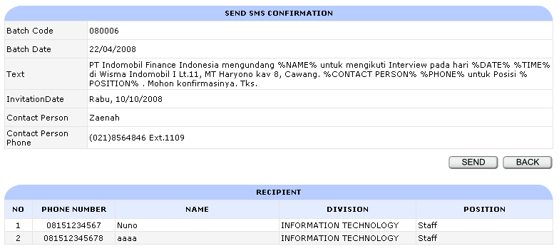

- Fungsi
- Menampilkan data Batch dan mengirim data Batch SMS

- Table
- SR_BatchSMSHeader
- SR_BatchSMSDetail

- Reference Table
- SR_DivisionMaster
- SR_PositionMaster

- View
- vSR_BatchSMSDetail

- Button
      - Back
- Link ke SendSMSDetail
- Query String
- FormMode
- SaveMode
- StatusBatch

      - Send
- Insert data ke Table SR_Inbox
- Update data dari Table SR_BatchSMSHeader By NoDataBatchSMSHeader
- Link ke SendSMSDetail
- Query String
- FormMode
- SaveMode
- StatusBatch

Screen SRT0102 – SendSMSBrowse

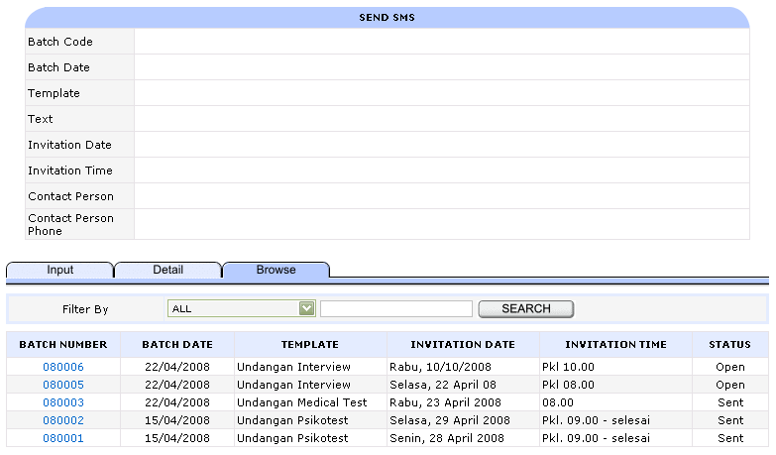

- Fungsi
- Menampilkan daftar Batch SMS

- Table
- SR_BatchSMSHeader

- Reference Table
- SR_TemplateMaster

- View
- vSR_BatchSMSHeader

- Filter
- Batch Number
- Batch Date
- Template
- Status Batch

- Hyperlink
      - BatchNumber
- Link ke SendSMSDetail
- Query String
- FormMode
- NoDataBatchSMSHeader
- StatusBatch
- SaveMode
- ClearSession

Screen SRT0200 – InboxPerBatchHome

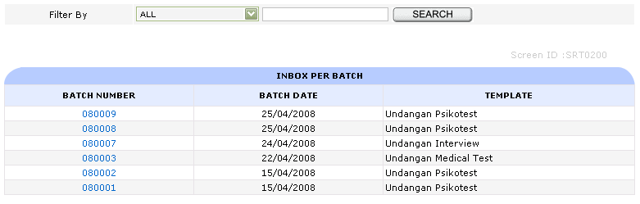

- Fungsi
- Menampilkan daftar Divisi

- Table
- SR_BatchSMSHeader

- View
- vSR_BatchSMSHeader

- Filter
- Batch Number
- Batch Date
- Template

- Hyperlink
      - Batch Number
- Link ke InboxPerBatch
- Query String
- FormMode
- NoDataBatchSMSHeader

Screen SRT0201 – InboxPerBatchDetail

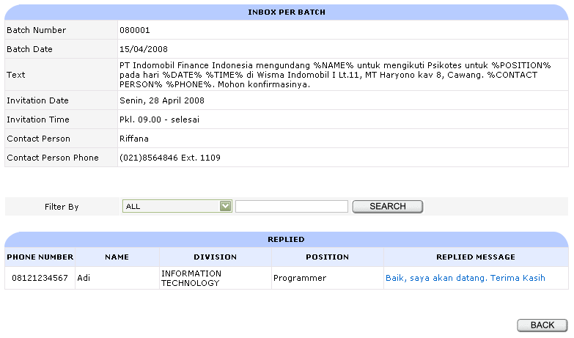

- Fungsi
- Menampilkan daftar Batch SMS beserta balasan SMS yang pertama kali dari penerima SMS

- Table
- SR_BatchSMSHeader
- SR_BatchSMSDetail

- Reference Table
- SR_Inbox
- SR_TemplateMaster
- SR_Division
- SR_Position

- View
- vSR_BatchSMSHeader
- vSR_BatchSMSDetailReceived

- Filter
- Phone Number
- Name
- Division
- Position
- Replied Message

- Button / Hyperlink
      - Back
- Link ke InboxPerBatchHome
      - Replied Message
- Link ke InboxPerBatch
- Query String
- FormMode
- NoDataBatchSMSHeader
- NoDataInbox
- StatusInbox
- InboxPerBatchMessageDisplay
- InboxPerBatchPhoneNumber

Screen SRT0202 – InboxPerBatchRepliedDetail

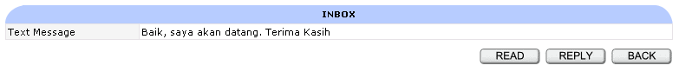

- Fungsi
- Menampilkan detil Message

- Table
- SR_BatchSMSHeader
- SR_Inbox

- View
- vSR_BatchSMSHeader

- Button
      - Back
- Link ke InboxPerBatchDetail
- Query String
- FormMode
- NoDataBatchSMSHeader
      - Read
- Update data dari Table SR_Inbox
- Link ke InboxPerBatchDetail
- Query String
- FormMode
- NoDataBatchSMSHeader
      - Reply
- Link ke Reply
- Query String
- FormMode
- NoDataBatchSMSHeader
- ReplyToPhoneNumber
- ReplyBackForm

Screen SRT0300 – InboxDetail

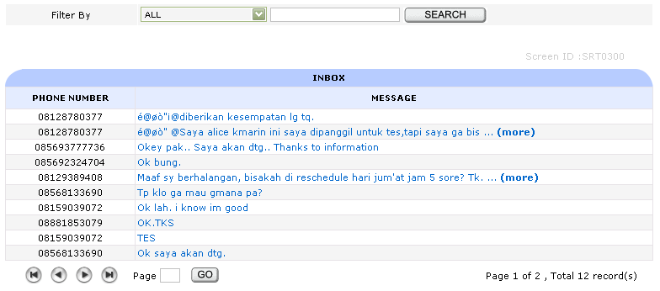

- Fungsi
- Menampilkan daftar SMS yang masuk

- Table
- SR_Inbox

- Filter
- From Phone Number
- Message

- Hyperlink
      - Message
- Link ke InboxPerBatch
- Query String
- FormMode
- NoDataInbox
- ClearSession

Screen SRT0301 – InboxDetail

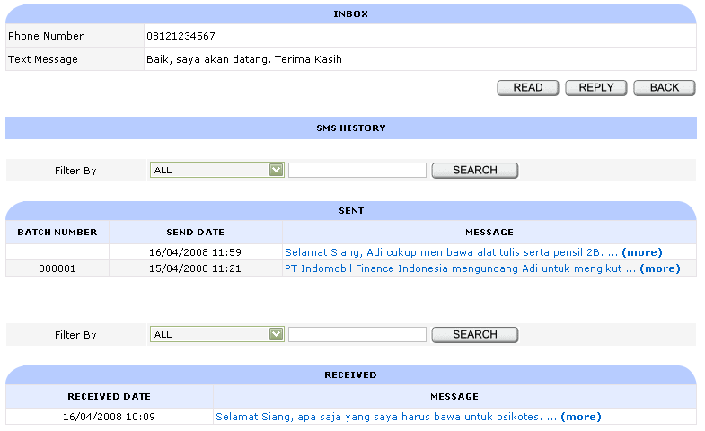

- Fungsi
- Menampilkan history pengiriman ataupun penerimaan SMS

- Table
- SR_Inbox
- SR_SentItem
- SR_BatchSMSHeader

- View
- vSR_SentItem_Batch

- Filter Sent
- Batch Number
- Sent Date
- Message

- Filter Received
- Received Date
- Message

- Button / Hyperlink
      - Back
- Link ke InboxHome
- Query String
- FormMode
- NoDataBatchSMSHeader
      - Read
- Update data dari Table SR_Inbox
- Link ke InboxPerBatchDetail
- Query String
- FormMode
- NoDataBatchSMSHeader
      - Reply
- Link ke Reply
- Query String
- FormMode
- NoDataInbox
- ReplyToPhoneNumber
- ReplyBackForm
      - Message
- Link ke InboxMessageDetail
- Query String
- FormMode
- NoDataInbox
- InboxHistoryMessage

Screen SRT0302 – InboxMessageDetail

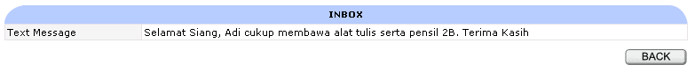

- Fungsi
- Menampilkan detil Message

- Button
      - Back
- Link ke InboxDetail
- Query String
- FormMode
- NoDataInbox

Screen SRC0100 – Reply

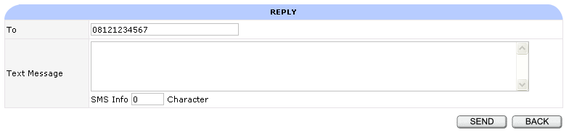

- Fungsi
- Mengirimkan balasan SMS dari SMS yang sudah diterima

- Table
- SR_SentItem

- Button
      - Send
- Insert data ke Table SR_SentItem
- Link ke InboxPerBatchDetail / InboxDetail
- Query String
- FormMode
- NoDataBatchSMSHeader / NoDataInbox
      - Back
- Link ke InboxPerBatchDetail / InboxDetail
- Query String
- FormMode
- NoDataBatchSMSHeader / NoDataInbox

